Minutes of Shalbourne Parish Council Meeting
Held on Monday 7th September 2026 at 7.30pm
Present: Victoria Astor, Hugo Fitzgerald, Mike Lockhart, Arabella Parton, Dianah Shaw, Bill Simpson,
- Introduction
  - The Chairman welcomed those present and opened the meeting
- Apologies for absence
  - Apologies were received from Andy Dolan, Sarah Samuuel, Bob Walker
- Declaration of Interest
  - There were no declarations of interest
- New Wiltshire Local Plan
  - The council discussed whether they should respond to the scoping consultation for the new Wiltshire Local Plan, in particular to the question of whether they should identify any sites that the community wished to be developed. It was agreed that the council should not respond to the initial scoping consultation.
- Planning Application for Carvers Hill Estate (PL/2026/04809)
  - After discussion it was agreed that the Parish Council should object to this application for a vehicle park, primarily because of the precedent being set. The proposed vehicle park is outside the settlement boundary and therefore within the Area of Outstanding Beauty. Any development requires a compelling reason. None is put forward in the Application.
- Any Other Business
  - There was no other business

The meeting ended at 20.04. The next meeting will be on 24th September.

ATTACHMENT 1
Background
The present approved plan runs out in 2026. Over the past 2(?) years Wilts Council have been drawing up a new plan for beyond 2026. A draft of this was put out for comment last (?) year. It showed no need for additional housing in Shalbourne. The plan was available in Marlborough. We have a copy of the Housing Need Assessment from that plan, too large to e mail but a copy of the Shalbourne entry is in Attachment 2.
Wilts Council submitted the plan to the Government who appointed two inspectors to examine it.
It was rejected in Jan 2026.
They are now having to write a new plan, hence the consultation.
The PC decided against commissioning a Neighbourhood Plan for Shalbourne as:
- Not value for money, cost £15,000+.
- Not much use. It identifies sites that the community want developed, we don’t admit to having any!
- Can be overridden by Gov policy etc.
If you are doing a write up would diffidently suggest 2 questions need to be considered:
- Do we want to identify any sites?
- If answer no, should we reply at all at this stage or minute for future reference that we have considered and the answer is no because …
- If we decide to reply – why? They are not asking for negative replies.

ATTACHMENT 2
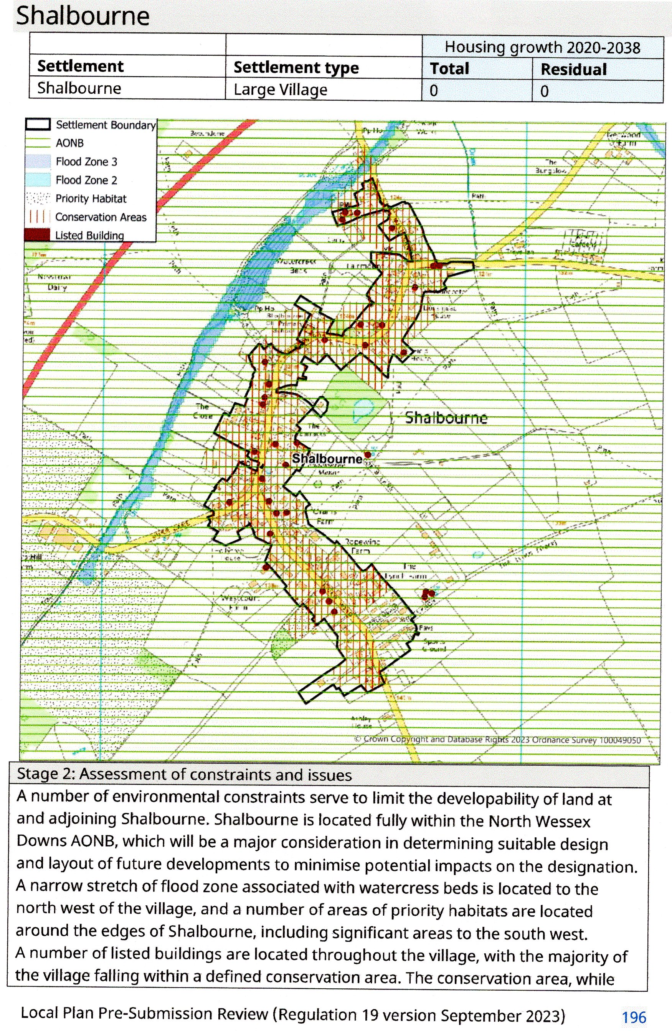
not a constraint to development in principle, would require careful design
consideration with respect to setting.
Land around Shalbourne is classified as a mix of Grade 2 and 3 Agricultural Land. The
loss of Best and Most Versatile (BMV) Agricultural Land should be avoided or
minimised through any subsequent site selection process.
The Wiltshire Strategic Flood Risk Assessment (2019) indicates high levels of
groundwater flood risk at Shalbourne. Site selection and allocation of sites for
development at the settlement will be required to carry out detailed assessment at a
local scale, addressing the sequential test and exceptions tests, where appropriate.
Overall, while the whole of the settlement falls within the AONB, some parts of the
settlement are more constrained than others. Shalbourne has no further growth
requirements. Therefore, no adjustment has been made to the requirement for the
settlement as a result of environmental constraints.
Shalbourne benefits from a limited range of everyday essential services and facilities
which support the resident population of the settlement. This includes the
Shalbourne Stores & Post Office local shop, and a public house (The Plough).
Additional housing development at Shalbourne has the potential to support the
ongoing vitality and viability of the services and facilities at the settlement.
Stage 3a: Consideration of education capacity
The residual requirement of 0 homes, due to existing commitments in the pipeline,
would result in no requirement for additional homes and therefore no additional
impacts on local education capacity. No adjustments to the settlement’s requirement
have been applied as a result of education constraints.
Stage 3b: Consideration of healthcare capacity
There is understood to be pressure on capacity within NHS healthcare services within
this Primary Care Network area which would require financial contributions to
ensure capacity for new patients. No adjustments to the settlement’s requirement
have been applied as a result of NHS healthcare constraints.
Stage 4: Assessment of past and projected rates of delivery
Shalbourne has seen a moderate level of growth in the past 15 years. Overall, 14 net
new dwellings were delivered between the years 2007-2022, equating to
approximately 0.9 dwellings per annum. This has slowed within the last 5 years, with
approximately 0.2 dwellings delivered per annum between the years 2017-2022.
As of 31 March 2022, the settlement did not have a made neighbourhood plan which
allocates sites for housing development.
There is a Local Plan residual requirement of 0 and no commitments in the pipeline
up to 2022. This represents a reduction from past rates of delivery.

ATTACHMENT 3
Wiltshire Council Planning Consultation Response
 | Officer’s Name: Joe Leesam
 | Direct Line: 01249 706619
Application No: | PL/2026/04809
Application Type: | Full planning permission
Proposal: | The proposed development comprises the laying of a permeable membrane with a hardcore/stone surface adjacent to the existing field access.
Site Address: | Carvers Hill Estate, Carvers Hill, Shalbourne, Marlborough, SN8 3PS

